Prelude:

1. The Landing Page is seperated into sections. Each Section taking in a full Screen size.
2. The loading Animation should be different (think of something funny, but still stylish) (what about a quote with a nice icon)
3. The Landing Page will only contain of one page, but there will be a footer which leads to subdomains. There will be following subdomains( each domain only taking one screen size: Impressum, Jobs, The Team, Our Vision, Press Kit, Contact, Earn Money(link to typeform). The content for this sections will be created by me in the next 2 days.
4. There should be some cool animations that fit our brand. This website will stay for the next 4 months. (some things will be added, but the basis will stay the same until we launch V2)

Section 1:

* Headline: Introducing Taskrookie.
* Animation just like in the website from appico
* More Info Button (Scrolls down)
* Earn Money Button (Link to Typeform)
* Big Logo
* Social Media Links
* Blurred out „Download in the App Store“ Badges

Combine those two somehow. Appico has a cool animation

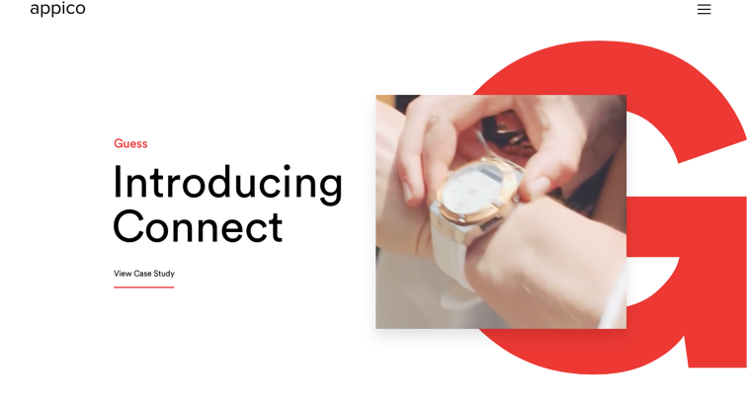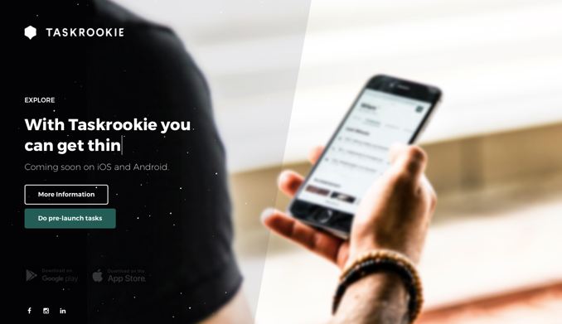

Section 2:

* Headline: Revolutionizing the way we find and book service providers
* Text 1: With Local On-demand service providers you can be sure to book the right people who fit your need in an instant
* Sub headline: What do you need? (Maybe an animation or a wireframe)

Sub Text: 1. Tell us what you need 2. You’ll receive offers from verified and licensed members. 3. They get the job done, and you pay cashless trough our safe payment system Taskrookie Pay.

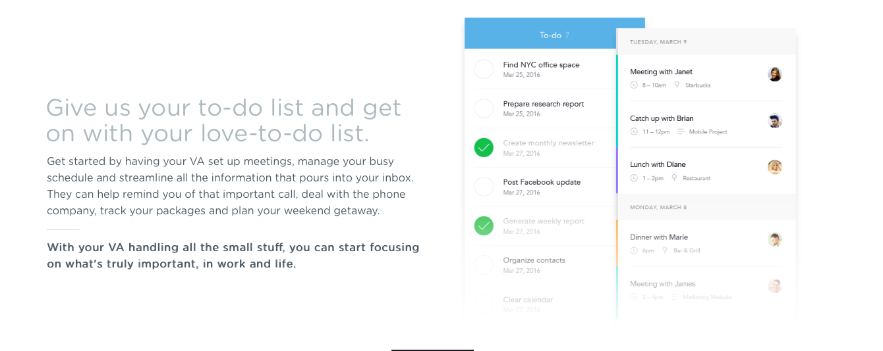

Section 3:

* Animation of the postig process
* Headline: Local service provider at the push of a button
* Subheadline: Technology makes it possible. 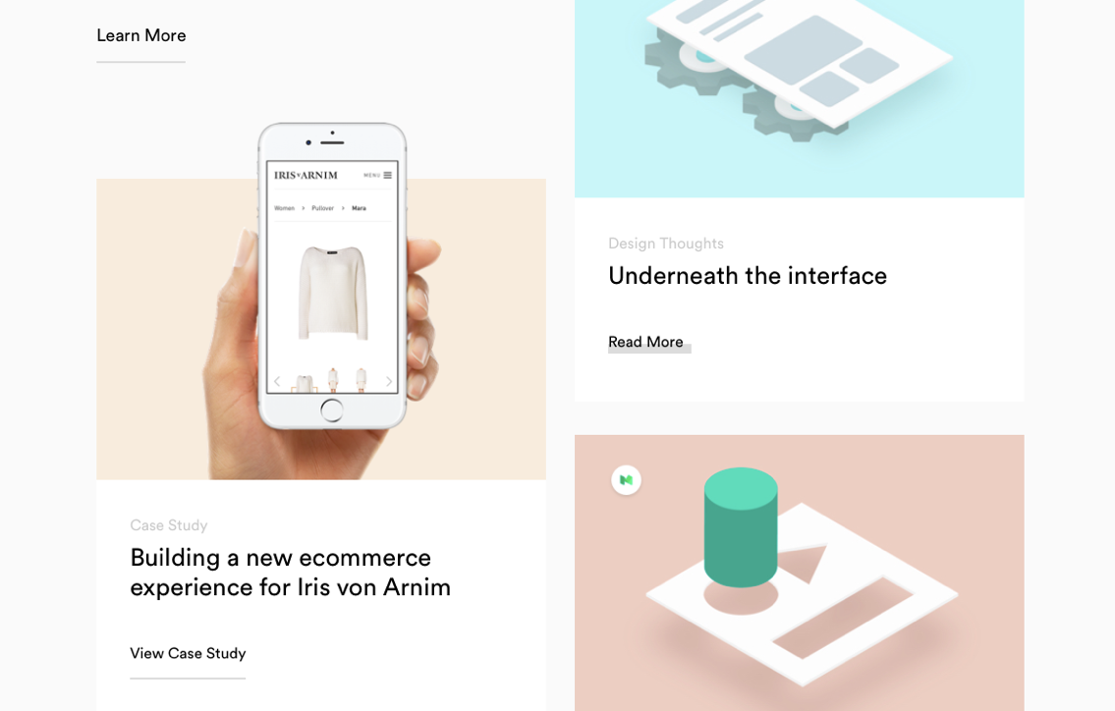

Section 4:

* Headline: Become a Pro on Taskrookie ans start growing your business
* Animation of how tasks would look like
* Text1: Thousands of people book services every day. By joinging our ecosystem you have direct access tot he demand. Make Offers and start growing your business today!
* Subheadline: Need spontaneos money? Start earning money now!(Link tot he typeform) 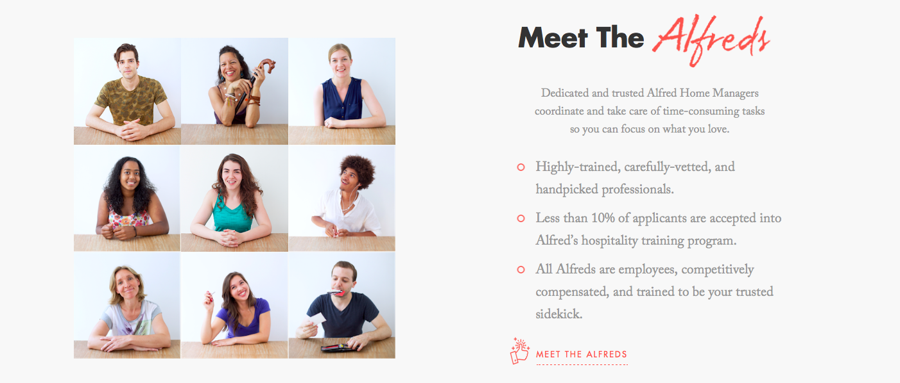

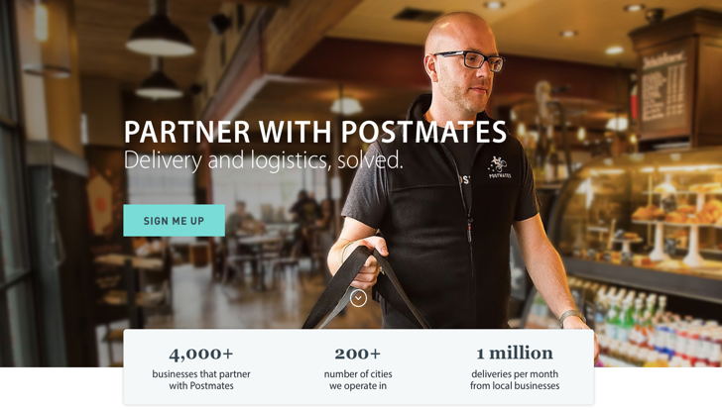

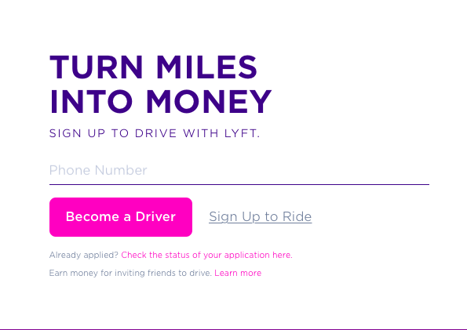

Section 5:

* Headline: We do more than just helping out. We make a change.
* Subheadline: We donate 5% of every transaction to a charitable organization of your choice.
* Logos of our partners

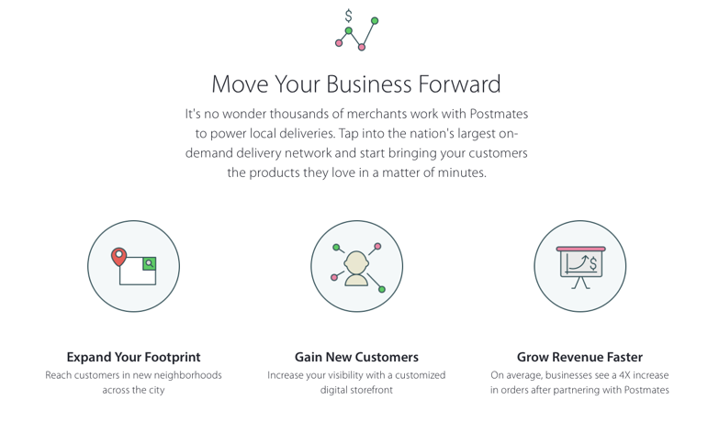

Section 6:

* Headline: With Taskrookie you can find service providers for services like these:
* This section ist o display the veriety of services you can do.
* Some product display wireframes
* Some cool animations and branding materials. 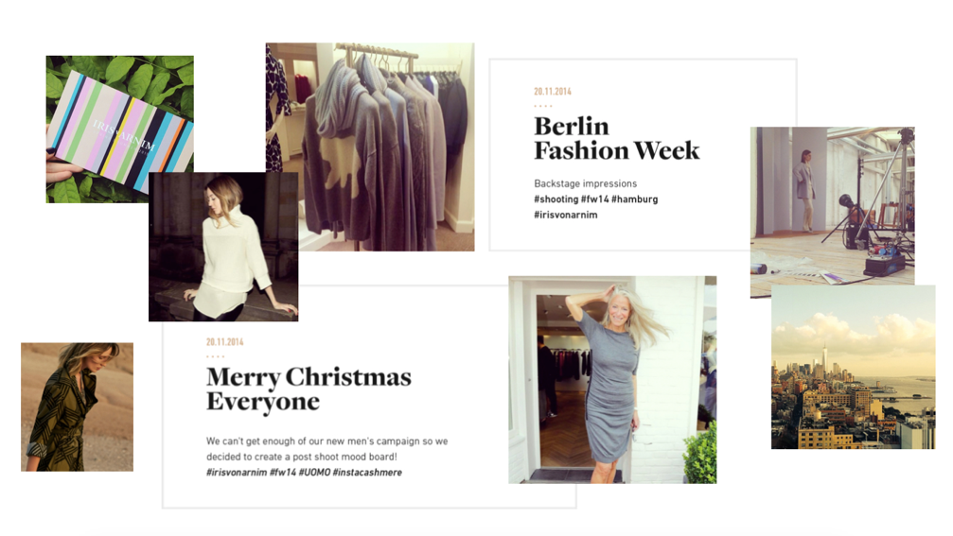

Section 7: Footer

* Plain Footer with everything in there and all the links.

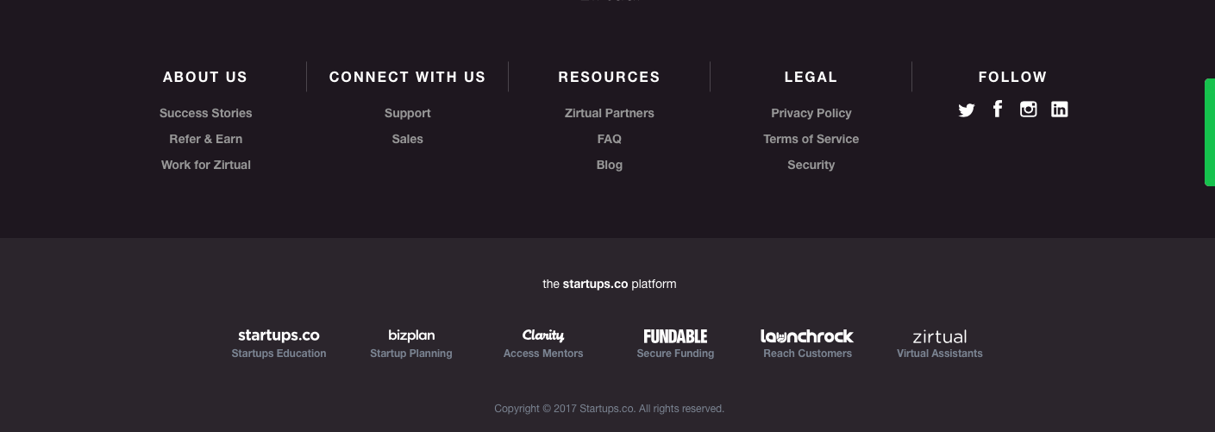

Ps: the texts are just for you to have a orientation. We will change the wording and the actual content based on how much space you have designed for it.

Be creative as f\*\*\*! Make a lot of overlays, just like in appico and the uber branding.   
Just create a fu\*\*ing nice landing page that gives everyone the vibezz.

Imagine you want to go on holiday, with beautiful girls and nice cold drinks. To Ibiza or St Tropez. Get those vibes into the website. Put in colours. Dont just use black & white. You can use everything. It just hast o fit our branding.

